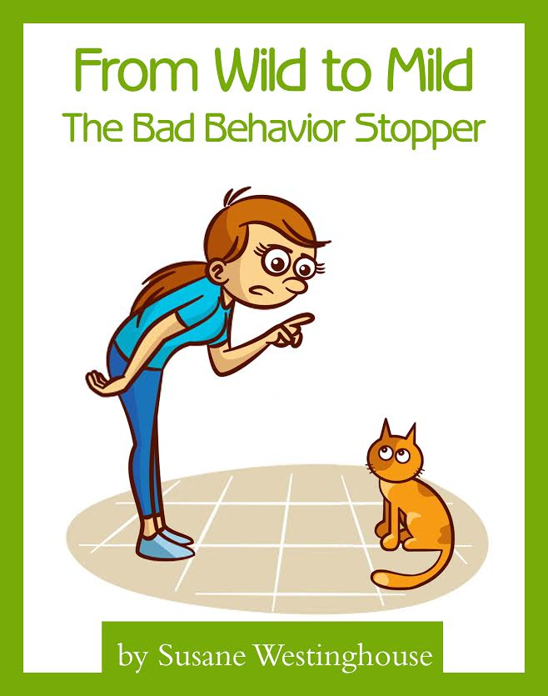

COPYRIGHT AND TRADEMARK NOTICES
This eBook is Copyright © 2016 Susane Westinghouse (the “Author”). All Rights Reserved. Published in the United States of America. The legal notices, disclosures, and disclaimers at the front of this eBook are Copyright © 2009 Law Office of Michael E. Young PLLC, and licensed for use by the Author. All rights reserved.
No part of this eBook may be reproduced or transmitted in any form or by any means, electronic or mechanical, including photocopying, recording, or by an information storage and retrieval system -- except by a reviewer who may quote brief passages in a review to be printed in a magazine, newspaper, blog, or website -- without permission in writing from the Author. For information, please contact the Author by e-mail at susane@catspraystop.com or by mail at 2972 Columbia St., 7144 Torrance, CA 90503.
All trademarks and service marks are the properties of their respective owners. All references to these properties are made solely for editorial purposes. Except for marks actually owned by the Author, the Author (as both author and as publisher) does not make any commercial claims to their use, and is not affiliated with them in any way.
Unless otherwise expressly noted, none of the individuals or business entities mentioned herein have endorsed the contents of this eBook.

LIMITS OF LIABILITY & DISCLAIMERS OF WARRANTIES
This eBook is a general educational pet-related information product.
As an express condition to reading to this eBook, you understand and agree to the following terms.
The eBook’s content is not a substitute for direct, personal, professional pet care and pet health diagnosis. None of the exercises or treatments (including products and services) mentioned in this eBook should be performed or otherwise used without clearance from your veterinarian or pet care provider.
There may be risks associated with participating in activities or using products mentioned in this eBook for cats in poor health or with pre-existing physical or mental health conditions.
Because these risks exist, you will not use this product with your cat or have her participate in such activities if she is in poor health or have a pre-existing mental or physical condition. If you choose to let her participate in these risks, you do so of your own free will and accord, knowingly and voluntarily assuming all risks associated with such activities.
The materials in this eBook are provided "as is" and without warranties of any kind either express or implied. The Author disclaims all warranties, express or implied, including, but not limited to, implied warranties of merchantability and fitness for a particular purpose. The Author does not warrant that defects will be corrected, or that that the site or the server that makes this eBook available are free of viruses or other harmful components. The Author does not warrant or make any representations regarding the use or the results of the use of the materials in this eBook in terms of their correctness, accuracy, reliability, or otherwise. Applicable law may not allow the exclusion of implied warranties, so the above exclusion may not apply to you.
Under no circumstances, including, but not limited to, negligence, shall the Author be liable for any special or consequential damages that result from the use of, or the inability to use this eBook, even if the Author or his authorized representative has been advised of the possibility of such damages. Applicable law may not allow the limitation or exclusion of liability or incidental or consequential damages, so the above limitation or exclusion may not apply to you. In no event shall the Author's total liability to you for all damages, losses, and causes of action (whether in contract, tort, including but not limited to, negligence or otherwise) exceed the amount paid by you, if any, for this eBook.
You agree to hold the Author of this eBook, the Author’s owners, agents, affiliates, and employees harmless from any and all liability for all claims for damages due to injuries, including attorney fees and costs, incurred by you or caused to third parties by you, arising out of the products, services, and activities discussed in this eBook, excepting only claims for gross negligence or intentional tort.
You agree that any and all claims for gross negligence or intentional tort shall be settled solely by confidential binding arbitration per the American Arbitration Association’s commercial arbitration rules. All arbitration must occur in the municipality where the Author’s principal place of business is located. Arbitration fees and costs shall be split equally, and you are solely responsible for your own lawyer fees.
Facts and information are believed to be accurate at the time they were placed in this eBook. All data provided in this eBook is to be used for information purposes only. The information contained within is not intended to provide specific pet care advice, or any other advice whatsoever, for any individual or company and should not be relied upon in that regard. The services described are only offered in jurisdictions where they may be legally offered. Information provided is not all-inclusive, and is limited to information that is made available and such information should not be relied upon as all-inclusive or accurate.
For more information about this policy, please contact the Author at the e-mail address listed in the Copyright Notice for this eBook.
IF YOU DO NOT AGREE WITH THESE TERMS AND EXPRESS CONDITIONS, DO NOT READ THIS EBOOK. YOUR USE OF THIS EBOOK, PRODUCTS, SERVICES, AND ANY PARTICIPATION IN ACTIVITIES MENTIONED ON THIS EBOOK, MEAN THAT YOU ARE AGREEING TO BE LEGALLY BOUND BY THESE TERMS.

AFFILIATE COMPENSATION DISCLOSURE
This eBook contains hyperlinks to websites and information created and maintained by other individuals and organizations. The Author does not control or guarantee the accuracy, completeness, relevance, or timeliness of any information or privacy policies posted on these linked websites.
You should assume that all references to products and services in this eBook are made because material connections exist between the Author and the providers of the mentioned products and services (“Provider”). You should also assume that all hyperlinks within this book are affiliate links for either (a) the Author or (b) someone else who is an affiliate for the mentioned products and services (individually and collectively, the “Affiliate”).
The Affiliate recommends products and services in this eBook based in part on a good faith belief that the purchase of such products or services will help readers in general. The Affiliate has this good faith belief because (a) the Affiliate has tried the product or service mentioned prior to recommending it or (b) the Affiliate has researched the reputation of the Provider and has made the decision to recommend the provider’s products or services based on the Provider’s history of providing these or other products or services. The representations made by the Affiliate about products and services reflect the Affiliate‘s honest opinion based upon the facts known to the Affiliate at the time this eBook was distributed by the Affiliate.
Because there is a material connection between the Affiliate and Providers of products or services mentioned in this eBook, you should always assume that the Affiliate may be biased because of the Affiliate’s relationship with a Provider and/or because the Affiliate has received or will receive something of value from a Provider.
Perform your own due diligence before purchasing a product or service mentioned in this eBook.
The type of compensation received by the Affiliate may vary. In some instances, the Affiliate may receive complimentary products, services, or money from a Provider prior to mentioning the Provider’s products or services in this eBook.
In addition, the Affiliate may receive a monetary commission or non-monetary compensation when you take action by clicking on a hyperlink in this eBook. This includes, but is not limited to, when you purchase a product or service from a Provider after clicking on an affiliate link in this eBook.
YOU SHOULD ALWAYS CONDUCT YOUR OWN INVESTIGATION (PERFORM DUE DILIGENCE) BEFORE BUYING PRODUCTS OR SERVICES FROM ANYONE VIA THE INTERNET. THIS INCLUDES PRODUCTS AND SERVICES SOLD VIA HYPERLINKS EMBEDDED IN THIS EBOOK.

Table of Contents

COPYRIGHT AND TRADEMARK NOTICES 1
LIMITS OF LIABILITY & DISCLAIMERS OF WARRANTY 1
AFFILIATE COMPENSATION DISCLOSURE 2
Introduction 5
CHAPTER 1: REBUILDING TRUST 7
CHAPTER 2: CORRECTING BAD BEHAVIORS 10
Counter Jumping 11
Door Darting 18
Plant Nibbling 22
Toilet Water Fascination 25
Faucet Fixation 26
Nighttime Symphonies 28
References 32

Introduction

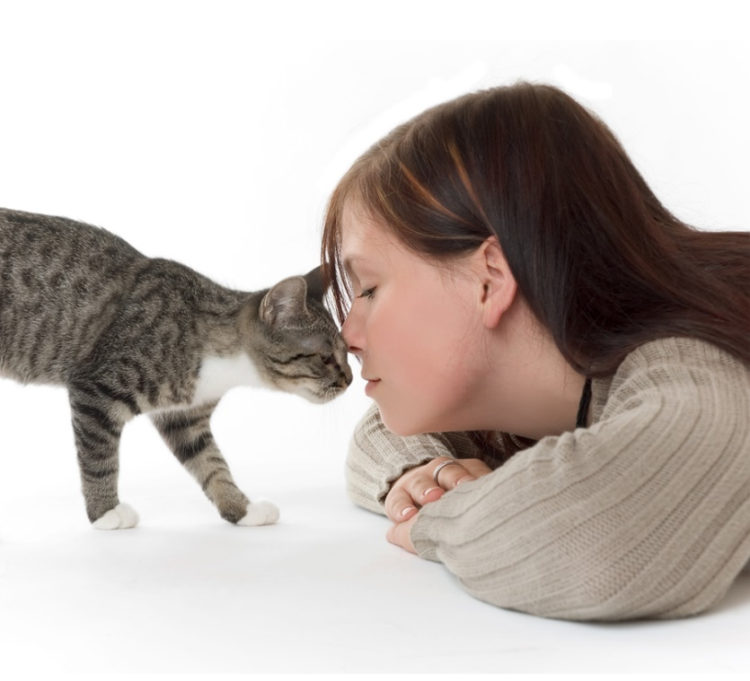

Your cat is a loving companion, a quiet listener, and a playful friend. She loves you unconditionally, forgives you endlessly, and entertains you constantly.
In other words, the cat seems to be the perfect pet. But as you know, appearances can be sometimes deceiving.
Cats, unlike dogs, choose domestication on their own terms. That is to say, their skills helped humans control rats and protect valuable grain in return for food, but one thing remained largely the same: their independent nature.
A cat is a feline, and by definition, felines enjoy the feeling of independence.
Unfortunately, that very independence can lead to many unwanted behaviors that many cat owners don’t really understand or can’t seem to eliminate.
Just think of counter climbing, door darting, plant nibbling, toilet water fascination, faucet fixation and nighttime “symphonies”. Does any of these images ring a bell?
Of course they do.
They are called ‘habits’, and they’re annoying. In fact, they’re so annoying that many cat owners are at their wits’ end.
Even worse, you may be at odds with your cat by now and the two of you might have a severely damaged relationship.
So let me ask you a question. Do you want these problems solved?
If your answer is yes – and I’m sure it is, because you love your cat – then you must know this: behaviors can be changed. Easily.
But to do this, you need to trust, respect, and most importantly, support your cat. In other words, you have to understand the cause first in order to ‘treat’ the effect efficiently.
Luckily, you have everything you need right here. Meet From Wild To Mild: The Bad Behavior Stopper. From now on, this is your cat’s behavioral guide. Keep it close, read it carefully, see your cat’s problems solved and your stress gone.

CHAPER 1 – Rebuilding Trust
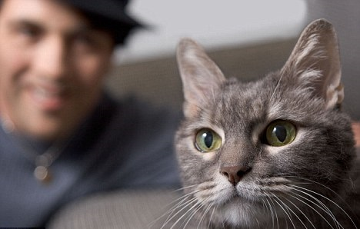

Whether you’re trying to correct a major problem that has your cat on her last chance or simply attempting to change a few annoying little habits, how you approach the situation is very important.
You may be at odds with your cat and the two of you might have a damaged relationship, but you have to put aside your emotional reactions to what has happened in the past in order to bring about a constructive solution to the problem that you are facing now.
Instead of getting angry or disheartened because your cat has failed to do something, reposition your attitude to focus on helping her succeed.
The thing is, you need to create an atmosphere that puts the cat in a better position to direct herself toward the desired behavior and away from the undesired one.
If the behavior issue you’re trying to solve has been a long-term one, keep your patience as you and your cat work through the behavior modification. Problems don’t occur overnight and they won’t be corrected overnight either.
When you do what needs to be done – the proper behavior modification – you’ll have the joy of watching your cat take firm steps in the direction you want.
The more you concentrate on those positive small steps, the easier the process will be for both of you.
Of course, it’s easy to get discouraged if, after things have been going well for a while, you experience a sudden setback. Don’t worry, that happens in all types of behavior correction.
People are as guilty of that as cats, so the best thing to do is to analyze what happened that created the setback, make the necessary adjustments, and move on.
You and your cat may not be the best of friends at the moment due to whatever behavior problem has been occurring, but you have to work on regaining her trust.
Don’t even think of starting behavior modification without reestablishing mutual trust. If you’ve used inappropriate correction techniques previously, there’s a good chance your relationship could use a little repair.
If you’ve punished your cat physically, she may just run away out of fear. You have to work on helping her see that your hands are not meant to inflict pain, but rather are for petting, holding, and showing affection.
Even if you haven’t issued physical reprimands, your cat may still be afraid of you, or at least somewhat cautious, if you’ve chased or yelled at her.
As a cat owner, you should be a source of security for your cat. Cats don’t have 9 lives. And security starts with your voice.
Pay attention to the tone of your voice when you talk to your cat now that you’re trying to regain her trust. Your voice should be calm and friendly.
Don’t use high-pitched tones because they’re not soothing. Convey softness.
Regardless of the problem you’re trying to correct, you need to be a pillar of comfort to your cat. How? Click here for more details.
Her behavior issue isn’t rooted in meanness – for this reason, it shouldn’t elicit similar feelings from you.

CHAPTER 2 – Correcting BAD BEHAVIORS
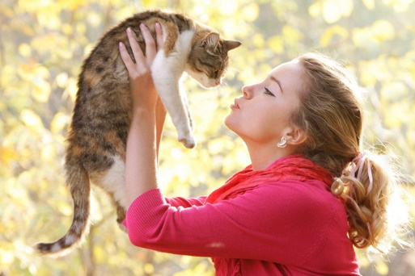

For some people, many of the problems that we’re about to discuss are not deal breakers when it comes to life with a cat.
For many others, however, these behaviors are increasingly harder to accept day after day and year after year.
Some cats display these behaviors in very subtle – almost unnoticeable – ways, while others’ little annoying behavior issues result in a full-scale war between cat and owner.
Small annoyances may be something you thought you had to resign yourself to if you were going to live with a cat, but they are, more often than not, easy to correct.
As with large problems, you have to understand what the underlying cause may be or why the cat feels the need to exhibit and stick to that particular behavior.
Even if a particular little annoying habit is acceptable to you and has become a normal way of life at this point, it may not be a healthy behavior for your cat, either physically or mentally.
Some little behaviors need to be modified for the cat’s sake, some for your sake, and some need modifying for both of you. Retraining makes life better for everyone.

- Counter Climbing
Kitchen counters possess an almost magnetic attraction to cats. For this reason, I’m pretty sure you have battle in vain for years to keep your cat of them. My question is, have you given up and surrendered them to her, or do you continue to shoo and chase several times a day?
Many people keep spray bottles on the counter and, from time to time, grab one, aim, and squirt.
Unfortunately, the only thing that is accomplished this way is that a wet cat leaps from the counter and dashes out of sight, frustrated but determined to try again later.

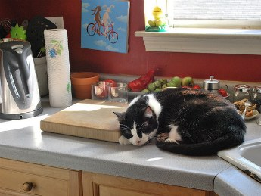
Perhaps having a cat on the counter didn’t bother you before but the situation changed due to the addition of a new family member who doesn’t agree with your choices or has allergies, or because you’ve moved to a new home.
Perhaps the battle heats up only when there’s food present, or maybe you allow your cat on the counter when you’re alone but would prefer not to when there are dinner guests present.
If you’ve allowed her there under certain conditions, then you’ve sent her a mixed message.
Don’t forget that cats are creatures of habit, and the training has to be consistent – the cat is either allowed or not allowed. Period.
If you prefer the second choice, then it’s time to do some proper retraining.
You may have tried multiple methods only to have your cat continue to leap up on your newly cleaned counter.
The problem with many of the methods used – whether it’s chasing, yelling, or even gently shooing her off – is that your smart kitty knows that all she has to do is wait you are no longer around to get right back up there.
Since you’ll be taking a preferred area from her, you’ll need to give her a more acceptable option in return. That’s an essential part of the retraining process.
Just think about it. Your cat hasn’t been jumping on the counter all these years simply because she enjoys being yelled at.
The counter has been an appealing place, and now you’re going to take that away. You have to give her something just as good or, hopefully, even better.
First, try to figure out what it is about the counter that appeals to your cat. For many cats it’s because of all the delicious food prepared there, whether it’s her own cat food in the process of being served or the roasted stake you just took out of the oven for your family.
In addition to the retraining process, you’ll need to make sure she’s not having to wait too long to get her meals. If you feed her by schedule, she may need the portion divided up into smaller meals fed more frequently – like THIS.
If she’s underweight, she may be due for a check-up by her vet to make sure there isn’t any underlying medical problem.
Conversely, if your cat is overweight, there might be not enough stimulation for her and all she thinks about is the next meal. Again, a veterinary check-up is advised.
Okay, but what if your cat is healthy, her meals are scheduled appropriately, and yet she still attempts to steal food, then what?
Many cats just can’t resist the opportunity to check out the enticing aromas that come from the food on the counter.
While you’re doing the retraining, reduce temptation as best as you can. Cover foods that must be left out on the counter as soon as possible. Don’t leave dirty dishes with leftover food on the counter or in the sink – less temptation, the faster the retraining will progress.
Second, your cat may not have any interest in the food on the counter. She may simply enjoy the fact that it’s an elevated area that’s very open and overlooks a wide space.
Perhaps there’s a window in the kitchen and the counter provides her with the possibility of watching birds or napping in the sun. It’s a natural part of a cat’s life to seek elevated areas and to climb, leap, and explore.
Your living space may not have enough elevated areas for your cat and she may have decided that the kitchen counter was the most appealing.
Maybe she just enjoys being with you and sitting on the kitchen counter while you’re preparing meals is an easy way to get close.
If you’ve concluded that your cat just enjoys being up there for the sake of it, provide her with an alternative that’s acceptable when you begin retraining.
A cat tree is an excellent solution. If you don’t have one, you might consider buying one. If you’ve had one for a number of years yet your cat ignores it, the problem might be its location, height, or stability. Place a sturdy tree near a window or at least in a room where you spend most of your time.
Third, some cats use the counter for safety purposes. This is seen more often in a multicat household, but it can also be due to a companion dog in the home or children.
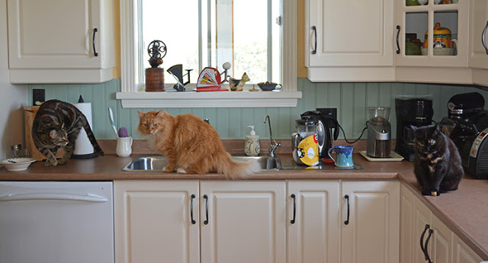
The counter is elevated and provides the cat with a comforting, wide visual field. If the kitchen is small and closed in, the cat may feel more protected up there in case someone suddenly comes in.
In a multicat situation in which there’s some tension, she may be on the counter ready to chase another cat out of the feeding area, or maybe she’s afraid that she’s going to be the one chased away.
If you think your cat prefers the counter due to a safety issue, you’ll need to do some retraining work on her relationship with others in the home.
Environmental modifications may need to be done to make sure the litter box is secure and the feeding station is safe. If she’s fearful of a dog or a child, work on improving those relationships.
What I’ve listed above are the three most common reasons why a cat tends to stay on the kitchen counter. Now, you’re ready to begin the training.
The method you’re going to use will be sort of remote-controlled, but you won’t need any batteries or devices. Everything will be very low-tech, but very efficient.
The cat must think this is a mysterious change in the object itself and not something coming from you. This protects the relationship between the two of you and allows the retraining to continue even when no one is at home.
Here are a couple of methods to tackle the problem.
Get a plastic carpet runner that has little nubs on the underside. Cut the runner so the pieces will fit the entire counter surface area. Place the runner with the nubs up. This creates a very unappealing surface for the cat to land or spend any amount of time on.
Put the carpet runner on the counter every time you don’t need to use it. By cutting pieces, you can remove only some sections so the vacant area of the counters will still be protected if you’re working on part of it. Before you leave the kitchen, replace the runner.
The reason behind this strategy is to make your cat understand that the counter isn’t the fun place it used to be. After a couple of weeks, you should be able to remove the runners.

If the carpet runner method hasn’t worked, you still have one last trick up your sleeve. Take some empty soda cans and/or plastic bottles, put a few pennies inside them, and line them up along the edge of the counter, in front of the carpet protector.
If you use cans, securely tape over the openings, and for bottles, tightly twist the caps back on. With these homemade shake cans and bottles, it won’t take but a moment before your cat realizes this isn’t a fun place to be.
Don’t use the cans or bottles in a multicat home, though, because the sound can startle an unsuspecting cat who isn’t doing anything wrong.
Always choose the minimally aversive method, and remember to always provide a better option, such as a cat tree or window perch.
Remember that all behavior modification should be humane. Don’t do this.

- Door Darting
You open the door, and the next second the cat is out. For this reason, you have to literally squeeze out of the door in the morning to prevent your cat from escaping.
But after years of forcing yourself – and your guests – to inch sideways through the door opening, you had enough. Or perhaps a recent fear, in which your cat actually did dart outside and was lost for a while might have made you decide that things ought to change.
An outdoor cat who is now living indoors exclusively may still be a little confused about the change and might make a break for the door every time she gets the chance.
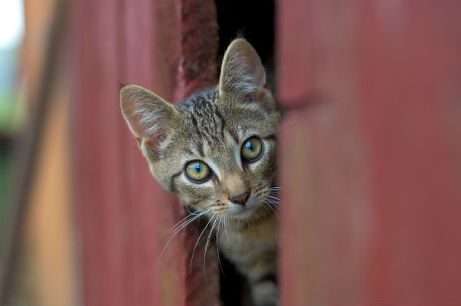
When you’re going through the phase of turning an outdoor cat into an indoor one, door dashing is one of the most common behavior problems that cat owners face, and one that continues to persist even after the cat seems to have accepted her new living setting.
The truth is, door darting is dangerous for the cat and scary for both cat and owner. Even if you do allow your cat to go outdoors, darting through the door is nothing else than bad training.
You don’t have time to decide if the conditions are acceptable for your cat to go outside if she just dashes out the door whenever she sees it open.
Even worse, a cat may have “trained” you to open the door to let her out whenever she meows or scratches at the door.
Therefore, if you cat darts out the door whenever she can, or whether you’ve become her “helping hand” by opening the door to do her bidding, the time has come to get things under control.
The first thing you need to do is to create an “official” greeting place in the room other than right inside the front door.
When you’re leaving the house and returning home, don’t say hello and goodbye right at the door. Choose another place in the room for greetings. It can be a chair, by the window, or on the cat tree. It doesn’t quite matter, as long as it’s consistent.
To get your cat accustomed to this new greeting place, designate it as an affection area. When you want to pet her, call her over to that spot. If she loves being groomed, brush her in that spot.
When you’re getting ready to leave, call your cat over to the designated greeting spot, give her the usual amount of affection, then offer her a treat or leave a toy there with her so you can walk away.
If she runs to the door, call her back to the greeting spot. Remember to keep your tone of voice calm and soothing. The thing is, if you establish a calm routine, she’ll very likely follow right along.
When you return home, ignore your cat if she’s standing right at the door opening. Walk over to the greeting place and call her over. There you can give her the type of greetings she enjoys. Consistency is key.
If your cat refuses to cooperate and still insists on this habit, you’ll have to follow another course of action.
Keep a spray bottle of plain water outside the door. Stand outside and open the door just a crack. If your cat is right there, give her a quick squirt of water.
The important thing to remember is that you don’t want her to associate this episode with your arrival. She has to associate it with the door.
After you’ve given the squirt, close the door, wait a few minutes then open it again just a crack. If she’s there, repeat the procedure then close the door.
Use this method whenever you come home and she’s right there, but don’t go inside the house immediately after the procedure. Wait several minutes so she’ll have time to regain her composure and be ready to greet you. If you move in to fast, she’ll know it was you doing that. Cats aren’t stupid.
The other behavior that often complements door darting is the demanding meowing, crying, and door scratching.
More often than not, this unwanted behavior actually gets rewarded by the cat owner, who can no longer stand the noise and opens the door. This, however, only leads to repeated episodes.
To address this problem, you need to use distraction as a method to change your cat’s focus from the door to something more exciting or entertaining.
When she sees that her indoor world has everything that she enjoyed about her outdoor environment, she’ll surely start to cooperate. Keep in mind, though, that this method won’t work if you haven’t created a cat-friendly environment.
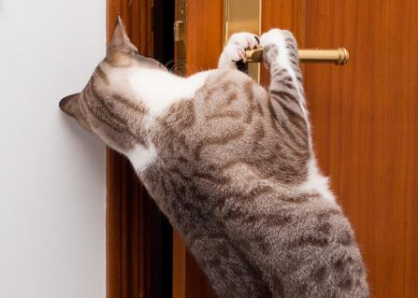
Distraction must occur while the behavior is still beginning to formulate in your cat’s brain, before she actually exhibits it.
For instance, if your cat always sits at the door and meows, distract her as she’s walking to the door. Use an interactive toy or just toss an interesting little object in her direction but away from the door.
Then create an interesting sound. You can keep a Plan-N-Squeak mouse handy and shake it to make that squeaking-mouse noise.
Timing is essential here because you have to do the distraction before the actual behavior takes place, or you’ll be rewarding the very behavior you don’t want. If your cat is predictable in terms of when she typically heads toward the door, use that knowledge and be ready to distract her. The more often you successfully diver her away from the door to something positive, the better your chances of permanently breaking that behavior.
If you missed your opportunity for distraction or your cat started meowing at the door while you were in another room, ignore her. I know it’s hard to do that, but you need to break the pattern.

- Plant Nibbling
Cats are carnivores, right? Then why do they enjoy chewing on grass and nibble at other plants?
Cats seem to enjoy doing their own version of indoor hedge trimming by chewing on many types of indoor plants. The truth is, it’s a very dangerous activity for a cat, and in many cases it can be downright deadly.
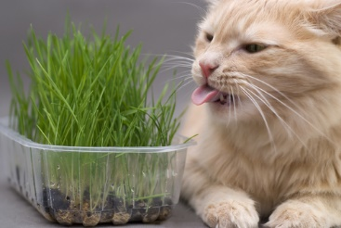
Most houseplants are toxic to cats. Some are toxic enough to cause illness, but others can kill. And it’s not only the exotic plants. Most of the common plants found in just about every home are actually toxic to cats.
In the wild, cats enjoy chewing on green grass. Zoologists and biologists have tried to pinpoint exactly what it is about grass that’s attractive to cats.
Although it has been determined that it’s not the chlorophyll, no one knows precisely what benefit the cat receives from eating grass. If a cat eats enough grass she’ll vomit, so many people seem to think this is the cat’s way of ridding herself of something unpleasant in her digestive system.
Since cats can feel the need to chew on some greenery, their only option is usually one of your houseplants. There are so many plants that are toxic to cats that it’s best to assume none of the plants in your home should be within your cat’s reach if she’s a chewer.
The way to deal with a plan nibbler is to set up deterrents on the plants.
There are bitter anti-chew sprays that can be used on the plants to make very unappetizing to your cat, and they’re widely available at pet supply stores and online.
Place newspaper around the base of the plants to catch any overspray. Spray the tops and bottoms of the leaves with the product.
Wear disposable gloves when you’re doing this so that the hand touching and moving the leaves doesn’t get saturated with the product.
Wash your hands after applying it.
The spray may have to be reapplied every few days, depending upon how determined your plant-nibbling cat is.
Provide your cat with a better alternative by purchasing a kitty-greens kit at your local pet supply store. With a little water and a few days’ time, you’ll have a pot of fresh grass.
After the blades are long enough, put the container in a sunny spot for kitty’s munching pleasure.
You can also grow a catnip plant. Packets of catnip seeds can be found at your local gardening center.
Kitties love them and they’re not harmful.

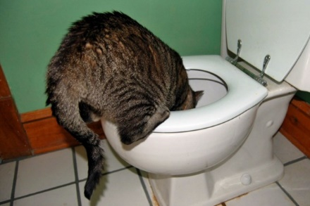
- Toilet Water Fascination

It isn’t a pleasant sight to walk into the bathroom and find your cat standing at the toilet with her front paws on the rim and her head near the water. As you hear the sound of lapping water, you cringe – you know exactly what’s happening. Moreover, your cat may also enjoy pawing at the water as she watches her rippling reflection.
If your cat enjoys quenching her thirst with water from the toilet, the most obvious solution would be to keep the lid closed so she doesn’t have access to it. In theory, that’s fine. The reality, however, may differ.
How many family members will comply with that rule on a daily basis? In addition to establishing a “keep lid closed” rule, there are some ways you can help your cat find healthier and safer places to drink.
The reason some cats choose the toilet water is because it’s often cooler than the water that has been sitting in their bowl.
Also, even if it may come as a surprise, it can taste fresher because it contains more oxygen from the flushing.
The water in your cat’s water bowl may have been sitting there for days and tastes as stale as can be.
It can also be a location preference. If you have the water and food in a double dish or individual dishes that are too close together, your cat may not like food particles into her water.
To fix the toilet drinking problem, make sure that her current water bowl is being kept clean and that you’re changing the water daily.
Even if it looks as though your cat hasn’t taken one sip from the bowl since you last changed it, replace the water every day.
Wash the bowl out, make sure there are no traces of dish detergent left on it, and then fill it with fresh water.
If you use a double dish for food and water, get two individual dishes and don’t place them next to each other.

- Faucet Fixation
People talk about this subject all the time. Their cats love to drink from either the bathroom or the kitchen faucet or simply enjoy pawing at the water.
Not surprisingly, in many cases the cats have actually “trained” their owners to turn on the faucet whenever they jump on the counter or meow at the sink.
While it may have been cute the first few times you watched your cat lapping at the water trickling from the faucet, you might have unintentionally set in motion a behavior pattern.
This faucet fixation can become so bad that some cats may then refuse to drink from their bowls.
To put an end to this behavior, you need to create an alternative to the faucet that’s more appropriate for your cat. There are pet water fountains available at pet supply stores and online that will provide your cat with the running water she enjoys.
The fountain also keeps the water more oxygenated, which adds to the appeal. Diabetic cats, ones in chronic renal failure, or those who have urinary problems need to drink more water, and the pet fountain can actually be a good way to encourage that.
If your cat doesn’t take to the fountain at first and still sits by the sink, place the fountain on the counter. Then, as she starts to use it, you can move it to the preferred location. Be sure you keep the fountain and all its parts clean. Don’t rely on the filter to do the work for you. The fountain requires more cleaning than a regular water dish, but in doing so you break the faucet fixation and to encourage your cat to drink more.

- Nighttime “Symphonies”
Even if it may come as a surprise, cats are not nocturnal. That’s only a misconception. But they’re crepuscular, which means they’re more active at dusk and dawn.
Since much of the prey a cat would normally hunt in the wild is also active at those times, this is a natural time for your kitty’s “surveillance” system to start revving up.
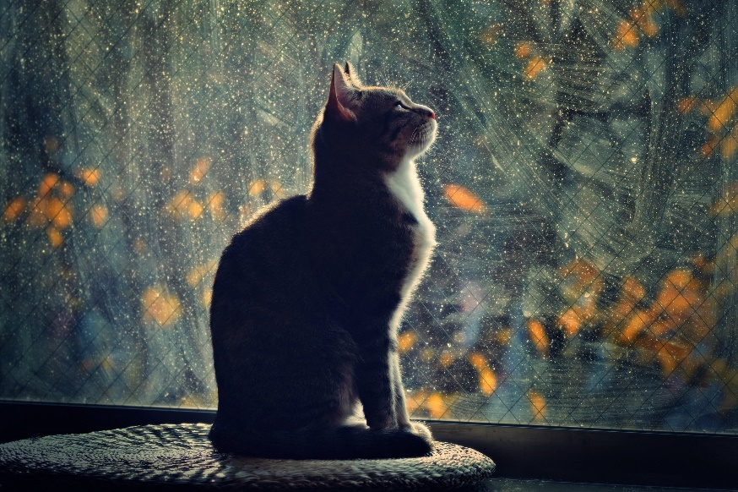
Much of the reason why your cat may be driving you nuts during those late-night hours when you’re trying – sometimes desperately – to sleep is because she isn’t getting enough stimulation during the day.
In other words, we work all day long and cats rest all day long. And when you’re home, they’re ready for activity. You, on the other hand, may not be.
For many cats, though, that “interaction” involves things like sitting on your lap or beside you while dinner is eaten, mail is read, or TV is watched.
But interaction does not equate with stimulation. When your system is winding down, your cat’s system is just revving up. That’s why when you get into bed, your cat may hang around for a while, but at some point her normal cat energy may be too difficult to contain.
Her keen senses are picking up on those interesting nightly noises or shadows and she may hear or see the insects just outside the window. More often than not, it can be too much for a cat to resist.
So, what’s to be done? Well, let’s see. Since the end of the day means winding down for you but revving up for your cat, you can do a little behavior modification to help reset her “biological” clock.
If you play with your cat during the early part of the evening, that’s great – keep that up. But that’s simply not enough. You need to add some more right before bed. And there’s a good reason for this.
In the wild, there’s a behavior cycle that repeats over and over again as the cat hunts. If you follow that cycle, you’ll have better success at getting her to let you have a good night’s sleep.
The cycle basically consists of four things: hunt, feast, groom, sleep.
The cat goes through the physical activity of hunting her prey. After the capture, she obviously eats her prey and then she grooms herself.
This grooming behavior is essential because the cat removes traces of the just-eaten prey so that other prey won’t be alerted to her presence and she doesn’t put herself at risk of larger predators.
When the grooming is completed and her stomach is full, she’ll be ready for a nap. The good news is that this four-part cycle can be applied to your indoor cat. Here’s how you do it.
If you schedule-feed your cat, divide up her portions so you can save one last meal for just before bed. If you free-feed, take up her food in the early evening.
Right before bed, engage in an interactive play session with her so she can work of the energy.
When playtime is coming to an end, wind the action down just as you do during your normal interactive play therapy sessions so she can have one final capture and be left relaxed.
Next, offer her the last portion of her meal. If you free-feed, put the food down and top it off with some fresh food.
After eating, she’ll most likely spend a little time on grooming, and then you stand a much better chance of having her curl up in bed beside you or stroll of into another room for a nap.
In order for this method to be successful, you must do the last play therapy session right before bed, not one or two hours before.
It might make you postpone your bedtime by fifteen minutes or so, but it’ll be worth it to get an uninterrupted night’s rest.
If you have a really active cat, or if she tends to rev up again a few hours later, set up some activity toys to keep her occupied while you sleep.
You can also try leaving the curtains or blinds open just a bit and place a cat tree nearby so your kitty can enjoy watching outdoor nighttime activity.
Besides these, other methods exist. Make sure to check them out.

REFERENCES:
The Cat Behavior Answer Book: Practical Insights and Proven Solutions for Your Feline Questions – Arden Moore; Storey Publishing; 2007
Cats: Expert Veterinary Advice On Feline Health And Behavior – Dr. Gordon Roberts; 2014
Cat Care: Kitten Care – How To Take Care Of And Train Your Kitten – Ace McCloud; CreateSpace Independent Publishing Platform; 2014
The Natural Cat: The Comprehensive Guide To Optimum Care – Anita Frazier; Plume Publishing; 2008

http://pets.webmd.com/
http://www.webvet.com/main/
http://www.vetstreet.com/

